OVERVIEW OF THE JOINT-DEGREE PROGRAMME
The ever-increasing demand for good public management of scarce resources has caused for a rethink about how public sector management and governance be taught in the higher institutions of learning. The Joint-Degree Programme aims to impart knowledge to students to be highly qualified specialists or experts and analysts of public administration.
Graduates at the end of their studies would have the capacity to critically incorporate fundamental knowledge on public governance and regional development in any public sector discourse. Additionally, graduates would have the abilities of scientific research and expert abilities in preparation and implementation of programmes in regional development.
The programme is organized to encompass Regionalism and Public Governance, social welfare, economic development of the public sector and research work with both compulsory and optional courses leading to the awarded degree as shown below;
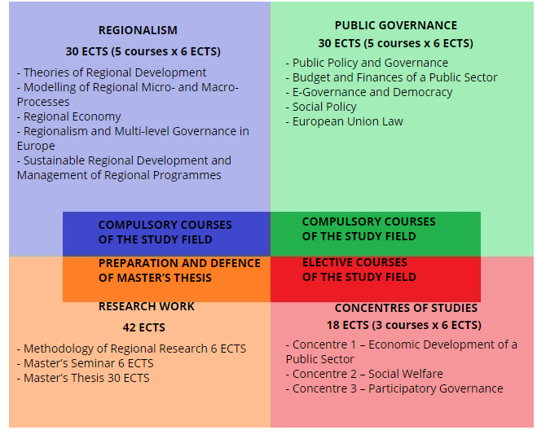
After a successful completion of all the study subjects of the Programme and defends of Master’s Thesis in Šiauliai University or by passing the state exam, which covers defence of Master‘s Degree and theoretical assessment, in University of Pardubice, the student will receive a joint master’s degree in Public Administration with European Diploma Supplement. The European Diploma Supplement indicates the recognition of the gained qualification when applying for work and study opportunities overseas.

